http://www.dotnettricks.com/learn/oops/object-oriented-programming-concepts:
Object-Oriented Programming Concepts (www.dotnettricks.com)
Author : Shailendra Chauhan
Posted On : 15 Feb 2011
Updated On : 10 Jul 2012

CRUD Operations using jQuery dialog, Entity Framework and ASP.NET MVC
This article will demonstrate, how to create an Asp.Net MVC application with CRUD (Create, Read, Update, Delete) Operations using jQuery and Entity Framework code first. suppose you have following data model and DataContext classes in EF.
- public class User
- {
- public int UserID { get; set; }
- [Required(ErrorMessage = "Please Enter Your Name")]
- public string Name { get; set; }
- [Required(ErrorMessage = "Please Enter Your Address")]
- public string Address { get; set; }
- [Required(ErrorMessage = "Please Enter Your Contact No")]
- public string ContactNo { get; set; }
- }

- public class DataContext : DbContext
- {
- public DataContext()
- : base("DefaultConnection")
- {

- }

- public DbSet<User> Users { get; set; }
- }
Now migrate your data model class into SQL Server database by using EF code first database migration. For more help refer this link Understanding Entity Framework Code First Migrations

Create Operation
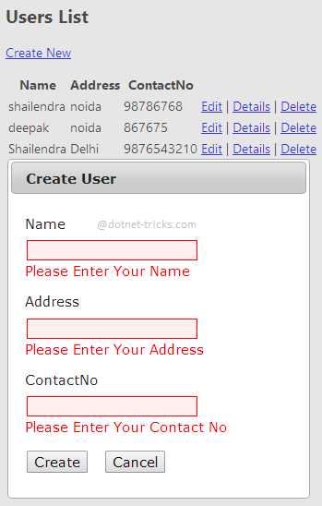
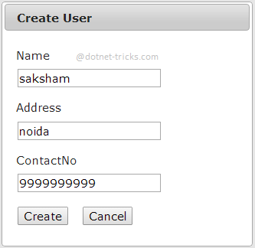
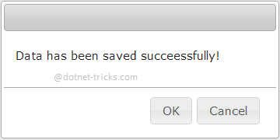

Read Operation
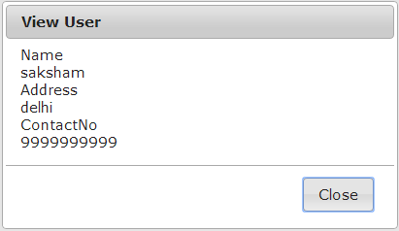

Update Operation
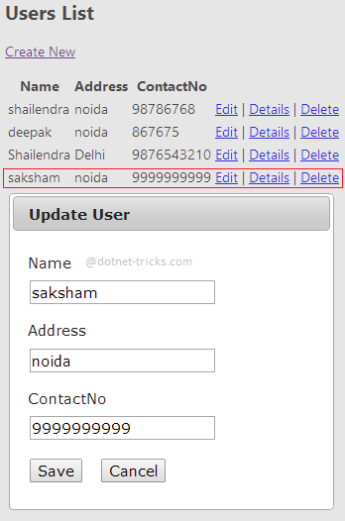
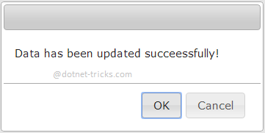

Delete Operation
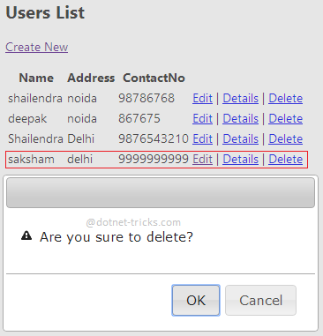
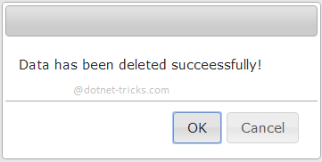

Making jQuery dialogs for CRUD Operations
- @model IEnumerable<jQuery_CRUD.DAL.User>
- @{
- ViewBag.Title = "Index";
- }
- <script src="~/Scripts/jquery-1.8.2.min.js"></script>
- <script src="~/Scripts/jquery-ui-1.8.24.min.js"></script>
- <link href="~/Content/themes/base/jquery-ui.css" rel="stylesheet" />
- <script>
- $(document).ready(function () {
- var url = "";
- $("#dialog-alert").dialog({
- autoOpen: false,
- resizable: false,
- height: 170,
- width: 350,
- show: { effect: 'drop', direction: "up" },
- modal: true,
- draggable: true,
- open: function (event, ui) {
- $(".ui-dialog-titlebar-close").hide();
- },
- buttons: {
- "OK": function () {
- $(this).dialog("close");

- },
- "Cancel": function () {
- $(this).dialog("close");
- }
- }
- });

- if ('@TempData["msg"]' != "") {
- $("#dialog-alert").dialog('open');
- }

- $("#dialog-edit").dialog({
- title: 'Create User',
- autoOpen: false,
- resizable: false,
- width: 400,
- show: { effect: 'drop', direction: "up" },
- modal: true,
- draggable: true,
- open: function (event, ui) {
- $(".ui-dialog-titlebar-close").hide();
- $(this).load(url);
- }
- });

- $("#dialog-confirm").dialog({
- autoOpen: false,
- resizable: false,
- height: 170,
- width: 350,
- show: { effect: 'drop', direction: "up" },
- modal: true,
- draggable: true,
- open: function (event, ui) {
- $(".ui-dialog-titlebar-close").hide();

- },
- buttons: {
- "OK": function () {
- $(this).dialog("close");
- window.location.href = url;
- },
- "Cancel": function () {
- $(this).dialog("close");
- }
- }
- });

- $("#dialog-detail").dialog({
- title: 'View User',
- autoOpen: false,
- resizable: false,
- width: 400,
- show: { effect: 'drop', direction: "up" },
- modal: true,
- draggable: true,
- open: function (event, ui) {
- $(".ui-dialog-titlebar-close").hide();
- $(this).load(url);
- },
- buttons: {
- "Close": function () {
- $(this).dialog("close");
- }
- }
- });

- $("#lnkCreate").live("click", function (e) {
- //e.preventDefault(); //use this or return false
- url = $(this).attr('href');
- $("#dialog-edit").dialog('open');

- return false;
- });

- $(".lnkEdit").live("click", function (e) {
- // e.preventDefault(); use this or return false
- url = $(this).attr('href');
- $(".ui-dialog-title").html("Update User");
- $("#dialog-edit").dialog('open');

- return false;
- });

- $(".lnkDelete").live("click", function (e) {
- // e.preventDefault(); use this or return false
- url = $(this).attr('href');
- $("#dialog-confirm").dialog('open');

- return false;
- });

- $(".lnkDetail").live("click", function (e) {
- // e.preventDefault(); use this or return false
- url = $(this).attr('href');
- $("#dialog-detail").dialog('open');

- return false;
- });

- $("#btncancel").live("click", function (e) {
- $("#dialog-edit").dialog("close");
- return false;
- });
- });
- </script>
- <div id="dialog-alert" style="display: none">
- <p>
- @TempData["msg"]!
- </p>
- </div>

- <div id="dialog-confirm" style="display: none">
- <p>
- <span class="ui-icon ui-icon-alert" style="float: left; margin: 0 7px 20px 0;"></span>
- Are you sure to delete?
- </p>
- </div>

- <div id="dialog-edit" style="display: none">
- </div>
- <div id="dialog-detail" style="display: none">
- </div>

- <h2>Users List</h2>

- <p>
- @Html.ActionLink("Create New", "Create", null, new { id = "lnkCreate" })
- </p>
- <table>
- <tr>
- <th>
- @Html.DisplayNameFor(model => model.Name)
- </th>
- <th>
- @Html.DisplayNameFor(model => model.Address)
- </th>
- <th>
- @Html.DisplayNameFor(model => model.ContactNo)
- </th>
- <th></th>
- </tr>

- @foreach (var item in Model)
- {
- <tr>
- <td>
- @Html.DisplayFor(modelItem => item.Name)
- </td>
- <td>
- @Html.DisplayFor(modelItem => item.Address)
- </td>
- <td>
- @Html.DisplayFor(modelItem => item.ContactNo)
- </td>
- <td>
- @Html.ActionLink("Edit", "Edit", new { id = item.UserID }, new { @class = "lnkEdit" }) |
- @Html.ActionLink("Details", "Details", new { id = item.UserID }, new { @class = "lnkDetail" }) |
- @Html.ActionLink("Delete", "Delete", new { id = item.UserID }, new { @class = "lnkDelete" })
- </td>
- </tr>
- }

- </table>

Controller for handling CRUD Operations
- public class UserController : Controller
- {
- private DataContext db = new DataContext();

- // GET: /User/
- public ActionResult Index()
- {
- return View(db.Users.ToList());
- }

- // GET: /User/Details/5
- public ActionResult Details(int id = 0)
- {
- User user = db.Users.Find(id);
- if (user == null)
- {
- return HttpNotFound();
- }
- return View(user);
- }

- // GET: /User/Create
- public ActionResult Create()
- {
- return PartialView();
- }

- // POST: /User/Create
- [HttpPost]
- [ValidateAntiForgeryToken]
- public ActionResult Create(User user, string Command)
- {
- if (ModelState.IsValid)
- {
- db.Users.Add(user);
- db.SaveChanges();
- TempData["Msg"] = "Data has been saved succeessfully";
- return RedirectToAction("Index");
- }

- return View(user);
- }

- // GET: /User/Edit/5
- public ActionResult Edit(int id = 0)
- {
- User user = db.Users.Find(id);
- if (user == null)
- {
- return HttpNotFound();
- }
- return View(user);
- }

- // POST: /User/Edit/5
- [HttpPost]
- [ValidateAntiForgeryToken]
- public ActionResult Edit(User user)
- {
- if (ModelState.IsValid)
- {
- db.Entry(user).State = EntityState.Modified;
- db.SaveChanges();
- TempData["Msg"] = "Data has been updated succeessfully";
- return RedirectToAction("Index");
- }
- return View(user);
- }

- // GET: /User/Delete/5
- public ActionResult Delete(int id)
- {
- User user = db.Users.Find(id);
- db.Users.Remove(user);
- db.SaveChanges();
- TempData["Msg"] = "Data has been deleted succeessfully";
- return RedirectToAction("Index");
- }

- protected override void Dispose(bool disposing)
- {
- db.Dispose();
- base.Dispose(disposing);
- }
- }

